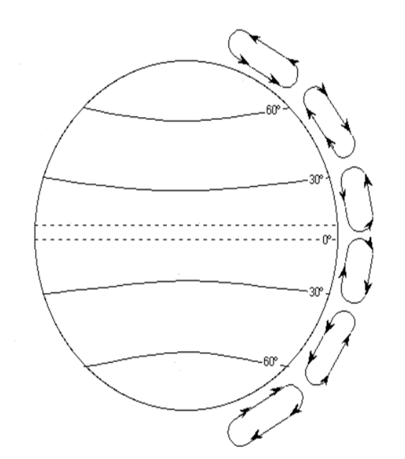
Task – Complete the diagram of the tri-cellular atmospheric circulation model.

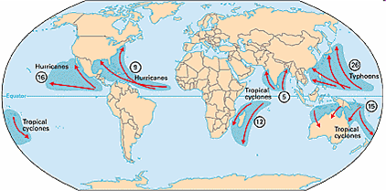
Task – Next explain the connection between atmospheric circulation and the global distribution of tropical storms (hurricanes, cyclones, typhoons). You may use the textbook to help you.

