Case Study: Eyjafjallajökull, Iceland Topic/s: Tectonic Hazards
Location: Iceland |  | 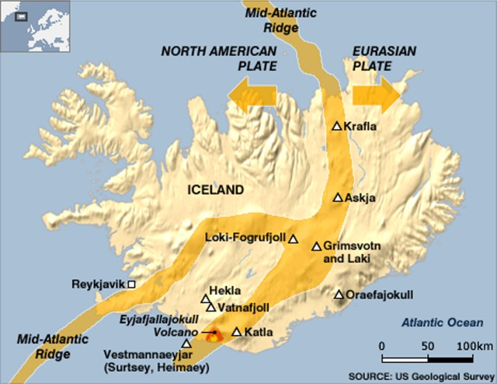  Iceland lies on the plate boundary of the North American plate and the Eurasian plate.  Not only is Iceland located on a plate boundary, it is also on a hot spot, this means it is an area where an abnormally hot volcanic plume of magma from the upper mantle rises to the surface.
Background Information Date: April 2010

Seismic activity started at the end of 2009 and gradually increased in intensity until on 20 March 2010. The second phase of eruption started on the 14th April. A relatively small eruption, despite the disruption it caused.

About the volcano
Stratovolcano - composed of alternating layers of ash and lava
Height 1666m above sea level
This volcano and its nearby larger neighbour, Katla, are located in the Eastern Volcanic Zone, which forms part of the Mid- Atlantic Ridge

The Eyjafjallajökull is an ice cap on the volcano. The Eyjafjalljökull volcano has erupted several times in the past, the previous major eruption occurring between 1821 and 1823
Sequence of Events
December 2009 - Increased seismic activity
February 2010 - ground deformation was detected, suggesting that magma was moving towards the surface. Earthquake activity continued to increase.
20 March - The first eruption occurred. Magma rose to the surface and was emitted from a number of vents on the flanks of the volcano in the form of lava flows.
14 April – increased seismic activity, 2nd eruption began. The second eruption occurred under the ice cap, which significantly increased its explosive power. The heat melted the ice, which vaporized. Ice quickly cooled the molten lava causing it to fragment into highly abrasive, glasslike shards of ash, which were then carried up in the eruption plume. The explosive power of the eruption was sufficient to carry the ash 9 km into the atmosphere. The eruption was rated at level four on the Volcanic Explosivity Index (VEI), which has a range of zero to eight.
21 May – lava stopped flowing, only steam was released
28 October - The eruption was officially declared to have finished.
Social  800 local people were evacuated due to flood risk.  People experienced long journeys to reach the airport on the north coast which remained open.  heavy ash fall on 7–8 May caused schools in southern Iceland to close  minor health problems as a result of the ash-fall e.g. eye irritations and dry throats  psychological impacts | Economic  an ash cloud that led to the closure of most of the European airspace from 15 until 20 April 2010.  Pastures, which were just beginning to grow again after the winter, suffered where ash-fall was deep – more than 10 cm. Leading to a temporary loss of earnings for some farmers.  Airport closures locally caused by ash-fall – passengers had to be bussed to an airport on the north coast.  Initially the eruption in March attracted tourists to Iceland during first stage of eruption – by the end of March, 10,000 people had visited the eruption.  However, the second phase closed air space across mainland Europe, preventing European visitors from going to Iceland between 15-20 April. |  | Environmental  Flooding – Meltwater emerged from the edge of the ice cap as a glacial burst causing flooding.  Local roads beside the Markarfljót river were washed away and the road between Hvolsvöllur and Vík was closed for several days.  Grass, crops and drinking water poisoned by fluorine-tainted ash.  Short-term decline in air quality  Mudslides - Mudslides (lahars) – ash mixed with meltwater and rain created mudslides or lahars. Mudslides falling into rivers raised channel beds, increasing the flood risk. Later in the summer, heavy rain falling on ash caused renewed concerns about flooding.  nutrients released from the ash improved soil fertility.
Impacts of Airspace closures

Many businesses lost money, some profited from the situation. About 7 million passengers worldwide were stranded as the result of airport closures. Many of these were on holiday and unable to return to work, which left businesses without employees. Estimated loss in productivity ~ £400 million a day

Many teachers and pupils were unable to return to school at a time when public examinations were approaching.

Air freight losses –products such as pharmaceuticals, justin-time deliveries of electronic devices, flowers and some exotic foodstuffs suffered. Hot-house flowers, for example, destined for European markets and worth an estimated £1.3 million, rotted in warehouses in Kenya.

Tourism – the airline industry suffered large losses, estimated by the International Air Transport Association at £1.2 billion worldwide over six days. Airlines had no passenger revenue and also had to cover the cost of re-routing planes and paying for the care of stranded customers. In contrast, companies who offered alternative transport to stranded passengers, such as rail companies e.g. Eurostar, and cross-channel ferries, gained from the disruption. Car rental firms, taxis and bus companies also saw an increase in business. Travel agents in the UK lost an estimated £6 million in business each day.

Several sporting fixtures and concerts were also cancelled, because players and performers were unable to reach their venues

Decline in aircraft air and noise pollution as the flight ban reduced aircraft carbon emissions over Europe

Response to the Hazard
Short term
- Engineers in some cases opened gaps in the road to allow meltwater to escape, to protect bridges from collapsing under the surge of floodwater.
- The European Red Cross Societies mobilized volunteers, staff and other resources to help people affected directly or indirectly by the eruption of the Eyjafjallajökull glacier volcano. Food was provided for the farming population that living in the vicinity of the glacier. They helped people to evacuate their homes.
- They also set up camp beds in numerous airports across Europe to help holiday makers that were trapped on their holidays due to the flight ban.
- Flight bans were put in place to minimise the risk from the ash cloud that spread across European airspace.

Long Term
- Reconstruction of roads, local flood defences needed reconstructing.
- Compensation to stranded travellers
- New regulations for volcanic ash in terms of flying aircraft.
- FutureVolc project set up in 2012 to integrate European volcano monitoring. Iceland is therefore a laboratory 'supersite' because of its array of volcanic sites.

