Case Study: Haiti Topic/s: Tectonic Hazards
Location: Haiti, Caribbean Island |  | 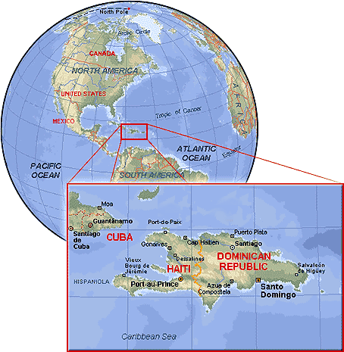
Basic Outline
- Magnitude – 7.0 on the Richter Scale
- Wednesday 13th January 2010, 16:53 local time.
- Lies closes to North American plate and the Caribbean plate. The earthquake occurred at a fault that runs through Haiti.
- The epicentre was near the town of Léogâne about 25 km west of the capital city of Port-au-Prince. By 24 January at least 52 aftershocks had been recorded, all measuring 4.5 or greater.
- LIC – ¾ of the population live on less than $2 a day
- Life expectancy 52 years
- High concentration of HIV/AIDs
- Approximately 1% of population control half the wealth.
- An elite 5% owns 75% of the arable land

Social  Initially 170,000 thousand people had died  In the end  over 230,000 died as result of primary and secondary impacts  300,000 injured  1 million made homeless  Medical facilities in Haiti were already poor, and the main hospital in Port-au-Prince had been destroyed.  Thousands of people needed water, food, medical supplies and shelter.  An outbreak of cholera was officially declared in October. | Economic  Destruction of roads, bridges, fishing ports and irrigation infrastructure had a serious effect on food production.  manufacturing facilities being damaged and workers lost or injured in the earthquake.  The developing tourism industry was disrupted.  250,000 residential buildings and 30,000 commercial buildings had collapsed or were severely damaged.  The port was destroyed.  Looting occurred in the days, weeks and months after the earthquake. | Environmental  Roads and building were damaged and destroyed.  The roads were littered with cracks and fault lines.  Sea levels in local areas changed, with some parts of the land sinking below the sea  water-borne illness developed due to pollution of water supplies  chemicals and oil leaked out of damaged storage facilities from damaged buildings – no major industrial pollution recorded | Political  feeding Haiti’s population was one of the government’s priorities before the quake, these efforts were suspended.  Many notable buildings were significantly damaged or destroyed including the Presidential Palace, the National Assembly building, the Port-au-Prince Cathedral and an important United Nations building in the capital.
Response to the Hazard
Short term
Water, food, tents, medicine and rescue equipment flown in from other countries
Emergency teams were also flown in equipped to help the estimated 3 million people

Six international and eight Haitian medical teams addressed health needs of the earthquake survivors through mobile medical clinics.

Some aid was sent into Haiti from the neighbouring Dominican Republic.

The Red Cross and other agencies sent a convoy of trucks carrying aid which included a 50-bed field hospital, surgical teams and an emergency telecommunications unit.

Huge amounts of aid were channelled through charities from many different countries. Millions of pounds of private donations also poured into appeals.

The UK
Late January Britons had donated £23 million to the Haiti earthquake appeal according to the UK Disasters and Emergency Committee
The UK government trebled its funding for the humanitarian response from £6.2 million to £20 million, to provide food, shelter, health and relief work.

The USA
Planes were sent full of rescue workers, an aircraft carrier and three amphibious ships with thousands of soldiers, along with a team to restore air traffic control to the airport.
long-term assistance to rebuild the shattered country was pledged

Satellite imagery and maps of the worst-affected areas as well as Geographical Information Systems (GIS) were used to help in the rescue efforts by making it possible to identify passable routes for relief and rescue workers as well as finding suitable for setting up aid camps where medical support and shelter could be provided.

Long Term
The EU gave $330 million and the World Bank waived the countries debt repayments for 5 years.

The number of people in relief camps of tents and tarps since the quake was 1.6 million, and almost no transitional housing had been built. Most of the camps had no electricity, running water, or sewage disposal, and the tents were beginning to fall apart.

One year after the earthquake 1 million people still remained displaced

The Dominican Republic which neighbours Haiti offered support and accepted some refugees.

