Task 1 – Sort the statements into the correct order
Hurricanes need a lot of heat to form and a sea surface temperature of at least 26°C, which is why they usually occur over tropical seas. They also need to be between 5 and 20° north or south of the equator. It works like this:

- Rising warm air causes the pressure to decrease at higher altitudes. Warm air is under a higher pressure than cold air, so moves towards the ‘space’ occupied by the colder, lower pressure, air. So the low pressure ‘sucks in’ air from the warm surroundings, which then also rises. A continuous upflow of warm and wet air continues to create clouds and rain.

- In the centre is the eye of the hurricane, about 45 km across (30 miles) across. Often there will be no clouds in the eye. Seen from below it will seem calmer, with a circle of blue sky above. The eye is formed because this is the only part of the hurricane where cold air is descending.

- Seen from above, hurricanes are huge circular bodies of thick cloud around 450 km (300 miles) wide. The cloud brings heavy rain, thunder and lightning.

- When this warm and wet air rises, it condenses to form towering clouds, heavy rainfall. It also creates a low pressure zone near the surface of the water.

- The faster the winds blow, the lower the air pressure in the centre, and so the cycle continues. The hurricane grows stronger and stronger.

- Air that surrounds the low pressure zone at the centre flows in a spiral at very high speeds - anti-clockwise in the northern hemisphere - at speeds of around 120 km/h (75 mph).

- In the northern hemisphere, the prevailing easterly tropical winds tend to steer hurricanes toward land - although their course is unpredictable. As hurricanes move inshore, their power gradually reduces because their energy comes from sucking up moist sea air.

- Air is ejected at the top of the storm – which can be 15km high – and falls to the outside of the storm, out and over the top, away from the eye of the storm. As this happens, it reduces the mass of air over the ‘eye of the storm’ - causing the wind speed to increase further. Some ejected air also cools and dries, and sinks through the eye of the storm, adding to the low pressure at the centre.

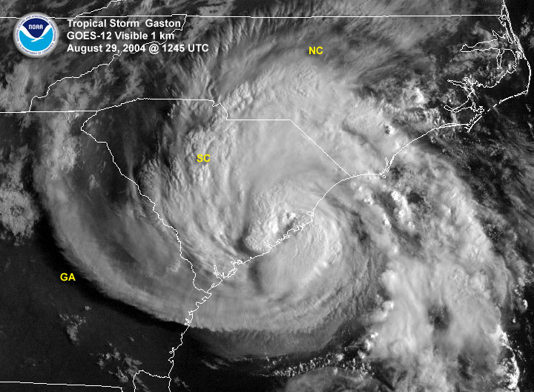
Task 2 - Label the following on your satellite image of a tropical storm.
- Eye
- Eye wall
- Continuous cloud cover
- Broken cloud cover
- Outer rain bands

Task 3 – Draw a labelled and annotated cross section of a tropical storm.
Use the following to help you annotate your cross section (they are in no particular order)
- Warm air from thunderstorms and from the surface of the ocean, combine and begin to rise causing low pressure.
- This is the eye of the storm, an area of low pressure and calm conditions.
- Located just outside of the eye is the eye wall. This is the location within a hurricane where the most damaging winds and intense rainfall is found
- The warm air rises faster and faster, this encourages more of the warmer air to be sucked up into the storm, but it also sucks cooler drier air down.
- Trade winds (winds moving into the low pressure) cause the storm to rotate in an anti-clockwise direction.
- As the hurricane moves across the ocean, it picks up more moisture and increases its speed.
- The outer edge of the Hurricane is a spiralling vortex or rain bands. It has high rainfall and high winds

